Taxi Trouble: Communication is key

Rob van Bekkum, Thijs Leo Martijn Brands,
Seyed Soheil Jahanshahi, Aidan Carl Antony Mauricio,
Joost Johannes Egidius van Oorschot
Delft University of Technology,
Delft, The Netherlands
R.vanBekkum@student.tudelft.nl
T.L.M.Brands@student.tudelft.nl
S.S.Jahanshahi@student.tudelft.nl
A.C.A.Mauricio@student.tudelft.nl
J.J.E.vanOorschot@student.tudelft.nl

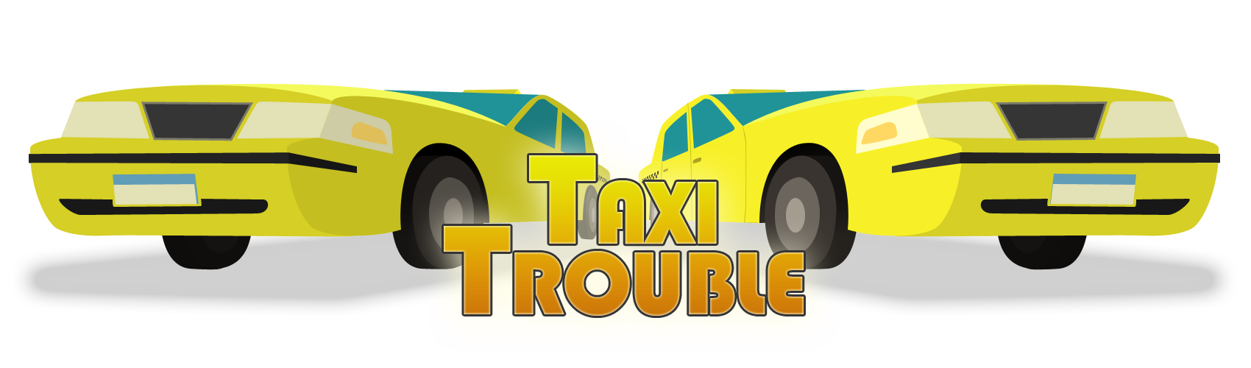

Copyright is held by the author/owner(s).

Abstract
In this document, the authors present the concept of the Android game Taxi Trouble, an interactive, competitive and collaborative multi-player game focusing on stimulating social interaction and entertaining large groups of people for a short timeframe.

Author Keywords
Student game design competition; Competitive and Cooperative gaming; Social Interaction;

ACM Classification Keywords
K.8.0 [Personal Computing]: General – Games.
K.4.m [Computers and Society]: Miscellaneous.

Overview
Taxi Trouble is a racing game developed with the purpose to entertain large groups of people who need to stay at the same place for a considerable amount of time. It is designed with the purpose to let people interact with each other. The game requires players to verbally communicate with each other. This game was developed as part of a second year’s project at Delft University of Technology, The Netherlands.

Background Research
In various situations large groups of people have to wait together at big events like festivals for a fixed period of time. As unpleasant waiting experiences may lead to negative evaluations of service [1] it is important to have a means of entertaining these large groups to improve their waiting experiences. Computer games are not just a form of entertainment for individuals anymore [2], and so making people participate in an interactive, competitive and cooperative computer game is a well-fitting, but also challenging way of improving these experiences.
Collaboration takes an increasingly larger role in playing computer games. The elements that make a game entertaining and stand out are the presence of activities that require collaboration, a shared experience of playing the game and getting satisfaction as a result of socializing with a group of people [3]. An entertaining game should as well make its players feel in control, but at the same should have a sufficient portion of unpredictability so that its players will feel a form of satisfaction and pride when their shared goal has been reached [4].
On the other hand at the same time competition in computer games takes an increasingly larger role as well. Including competitive elements in games allows more active player engagement and yields in getting direct feedback on the players' actions [5]. Also, playing a game against real people results in more involvement than playing against computer players [6].
Further it is important that a game for this specific context is of short duration and should be quite easy to understand as its players might only have a restricted available amount of time. As a consequence the game should not take long to setup and thus should be able to be played on almost every location.

Design and Development
Gameplay has become an integral part of the lives of many people especially when it comes to social interaction and communication. Based on our research we have designed our game model by creating a taxi which needs to be steered by a driver who is guided by a navigator. Each user of the game will take a role of either driver or navigator and will play the game through their respective view.
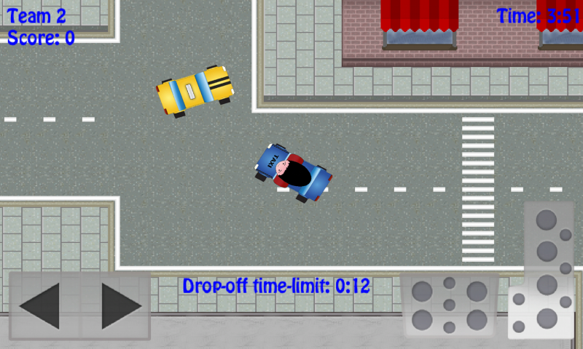
Figure 1. Driver view: team two's taxi carrying a passenger.
The players are guided to the game by a main menu where options are available for them to choose either to play a new game or to view the leaderboard. When players decide to start a new game they can decide on the amount of players to play with and wait for the other players to join. As soon as the game starts the players are assigned to teams of two randomly and get either the role of taxi-driver or navigator. The navigator then guides its partner to the right locations to pick-up passengers and drop them off at their destinations within the time limit. Points are awarded based on the amount of time the passenger has left at the moment of dropping him off. To make the gameplay even more entertaining and competitive, it is possible to steal a passenger from another taxi by bumping into it. We also introduced power-ups that can be picked up and activated by the navigator. A game takes five minutes. The team with the highest score wins.
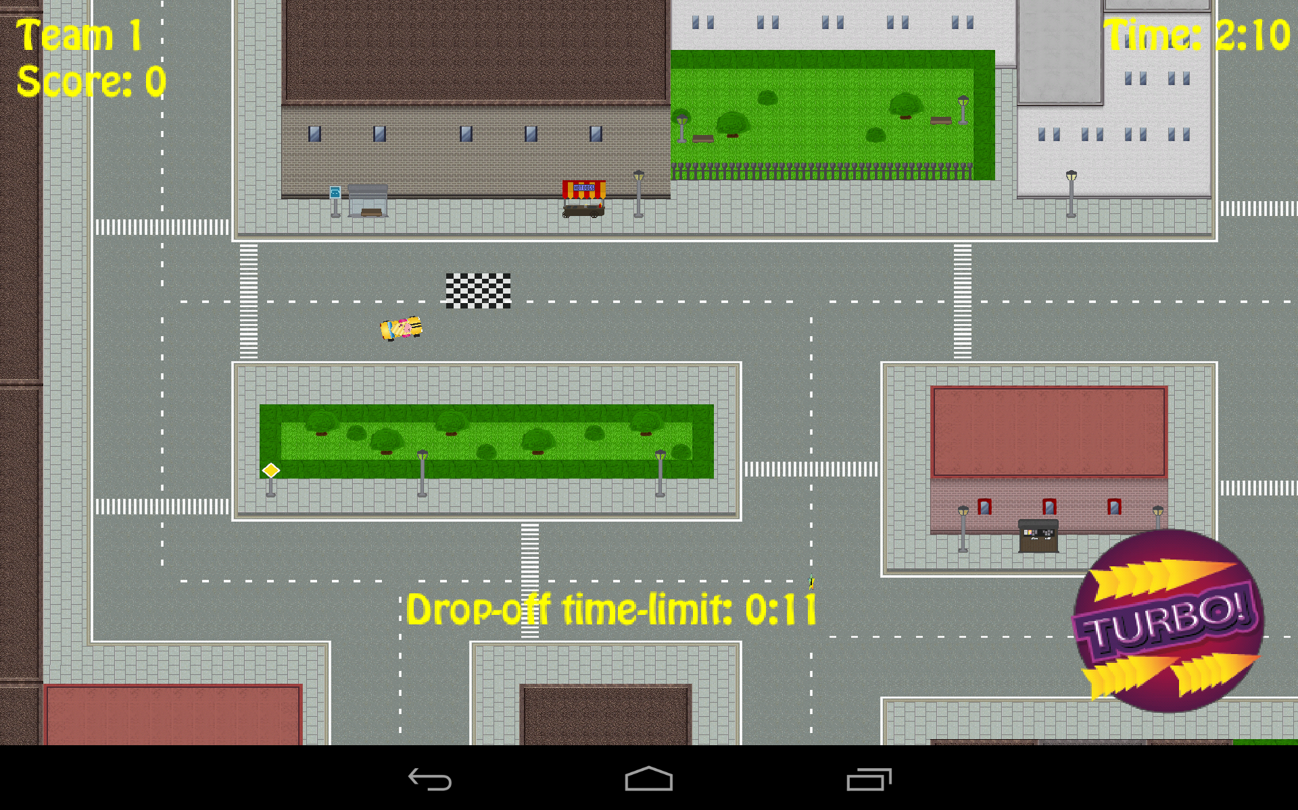
Figure 2. Navigator view: navigating to the destination.
Without the help of his navigator, the driver will not know where passengers, power-ups or opponents are. This makes the game impossible to win without communicating efficiently with your navigator.

Testing and Evaluation
Just before our product entered the beta stage, we held a User Test at Science Centre Delft. We choose this location on purpose as it mostly attracts people who are part of our target audience (ages 12-30).
Our test indicated that it is a bit troublesome figuring out how to play the game, as approximately 40% of the users indicated it took to long to completely understand the game. Once users understood the game, they all started communicating with each other. This showed that the “forced communication” aspect of the game really worked as intended.
The most important part of feedback we got was that players found that, while the game was fun to play, they felt that it was a bit too easy to score points. This was very valuable feedback to us and it resulted in the addition of a time constraint. This means that the actions necessary to score now have to be executed within a certain time frame. We found that this additional feature made our game more challenging and fun to play.
Despite the absence of this time constraint, users found our game a huge success, as nearly everyone said that they would like to have the game.
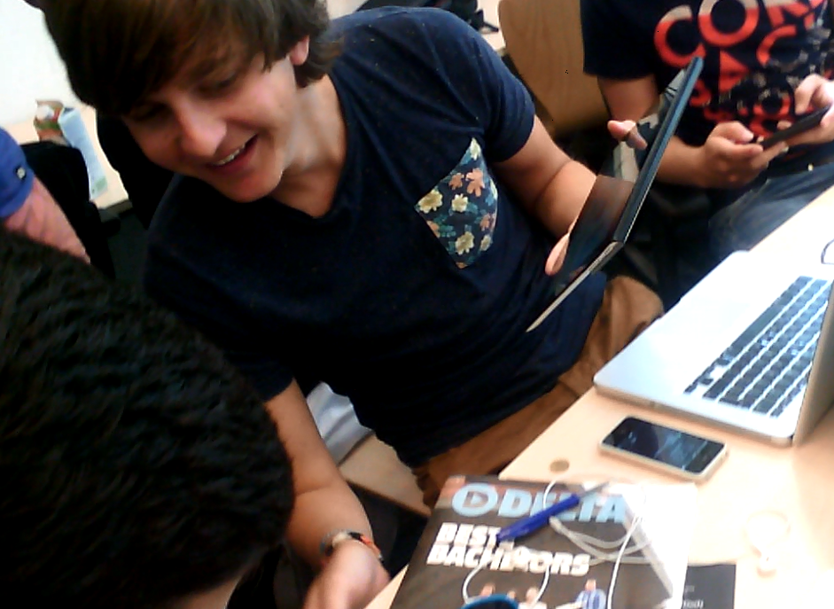
Figure 3. Gameplay tests: Players communicating with each other as driver and navigator.

Game trailer
A trailer for Taxi Trouble has been created showing the most important and distinguishing aspects in comparison to existing games. The video can be viewed at: [URL to be added when trailer is finished]

Acknowledgements
We would like to thank Delft University of Technology for facilitating the development of Taxi Trouble. We would like to thank all the teachers and teaching assistants concerned with organizing the context project. Special thanks go out to Rafael Bidarra, Bastiaan Reijm and Fanny Lie for supporting us throughout development. We also like to thank Jan-Willem van Velzen for his work on the artwork for our logo. Last but not least, we want to thank Science Centre Delft for facilitating our user tests.

References
[1] Yan, R.N. and Lotz, S. (2006). The Waiting Game: The Role of Predicted Value, Wait Disconfirmation, and
Providers’ Actions in Consumers’ Service Evaluations. In NA - Advances in Consumer Research, Volume 33, eds. Pechmann, C. and Price, L., pages 412-418, Duluth, MN, USA, ACR.

[2] Sellar, T. (2004). User experience in interactive computer game development. In Computer Human Interaction, pages 675-681.

[3] Ducheneaut, N. and Moore, R. J. (2004). The social side of gaming: a study of interaction patterns in a massively
multiplayer online game. In Proceedings of the 2004 ACM conference on Computer supported cooperative work,
CSCW ’04, pages 360-369, New York, NY, USA. ACM.

[4] Granic, I., Lobel, A. and Engels, R. C. M. E. (2013), The Benefits of Playing Video Games. Radboud University.
Nijmegen, NL.

[5] Vorderer, P., Hartmann, T., and Klimmt, C. (2003). Explaining the enjoyment of playing video games: the role
of competition. In Proceedings of the second international conference on Entertainment computing, ICEC ’03,
pages 1-9, Pittsburgh, PA, USA. Carnegie Mellon University.

[6] Cairns, P., Cox, A. L., Day, M., Martin, H., and Perryman, T. (2013). Who but not where: The effect of social
play on immersion in digital games. International Journal of Human-Computer Studies.

